EXTRA PROGRAMS

1

import java.util.*;

class array_sum

{

public static void main(String args[])

{

Scanner sc=new Scanner(System.in);

int n,even=0,odd=0;

System.out.println("enter array size ");

n=sc.nextInt();

System.out.println("enter values ");

int a[]=new int[n];

for(int i=0;i<n;i++)

a[i]=sc.nextInt();

for(int i=0;i<n;i++)

{

if(i%2==0)

even=even+a[i];

else

odd=odd+a[i];

}

System.out.println("sum of even indices = "+even);

System.out.println("sum of odd indices = "+odd);

}

}

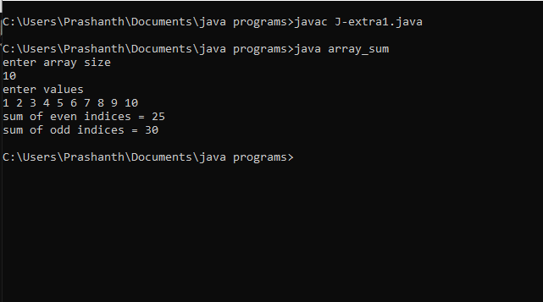

2

import java.util.*;

class array_count

{

public static void main(String args[])

{

Scanner sc=new Scanner(System.in);

int n,pos=0,neg=0,zero=0;

System.out.println("enter array size ");

n=sc.nextInt();

System.out.println("enter values ");

int a[]=new int[n];

for(int i=0;i<n;i++)

a[i]=sc.nextInt();

for(int i=0;i<n;i++)

{

if(a[i]==0)

zero++;

else if(a[i]>0)

pos++;

else

neg++;

}

System.out.println(" no of positive numbers = "+pos);

System.out.println(" no of negative numbers = "+neg);

System.out.println(" no of zeroes in array = "+zero);

}

}

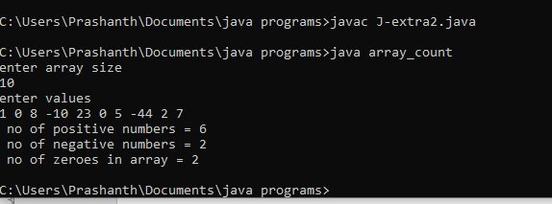

3

import java.util.*;

class market_bill

{

public static void main(String args[])

{

Scanner sc=new Scanner(System.in);

int x;

System.out.println("enter no of items ");

x=sc.nextInt();

double tot=0.0;

double rate[]=new double[x];

int quantity[]=new int[x];

for(int i=0;i<x;i++)

{

System.out.println("enter price of item and quantity ");

rate[i]=sc.nextDouble();

quantity[i]=sc.nextInt();

tot=tot+(rate[i]*quantity[i]);

}

double dis=0.0;

if(tot>=10000.0)

dis=5.0;

if((tot>=7500.0)&&(tot<10000.0))

dis=3.0;

if((tot>=5000.0)&&(tot<7500.0))

dis=2.0;

double total= tot-(dis*tot/100.0);

System.out.println("total bill amount before discount : "+tot);

System.out.println("final bill amount after discount : "+total);

}

}

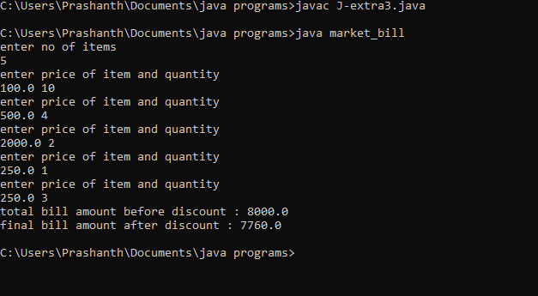

4

import java.util.*;

class array_abc

{

public static void main(String args[])

{

Scanner sc=new Scanner(System.in);

int n,even=0,odd=0;

System.out.println("enter array size ");

n=sc.nextInt();

System.out.println("enter values ");

int a[]=new int[n];

for(int i=0;i<n;i++)

a[i]=sc.nextInt();

for(int i=0;i<n;i++)

{

if(a[i]%2==0)

even++;

else

odd++;

}

int b[]=new int[odd];

int c[]=new int[even];

int x=0,y=0;

for(int i=0;i<n;i++)

{

if(a[i]%2==0)

c[x++]=a[i];

else

b[y++]=a[i];

}

double sum=0.0,avg;

int max=c[0],min=c[0];

for(int i=0;i<even;i++)

{

sum=sum+c[i];

if(c[i]>max)

max=c[i];

if(c[i]<min)

min=c[i];

}

avg=sum/even;

System.out.println("for array C:");

System.out.println("sum : "+sum);

System.out.println("average : "+avg);

System.out.println("maximum : "+max);

System.out.println("minimum : "+min);

}

}

